**Select this text, overwrite the title of your paper here, and capitalize the first word**

**Name SURNAME 1 \*** [](https://orcid.org/0000-0000-0000-0000)**, Name SURNAME 2** [](https://orcid.org/0000-0000-0000-0000)

1 Department of XYZ, Faculty of XYZ, XYZ University, City, Country.

2 Department of Pharmaceutical Chemistry, Faculty of Pharmacy, Marmara University, Haydarpaşa 34668 İstanbul, Turkey.

* Corresponding Author. E-mail: [xyz@xmail.com](mailto:xyz@xmail.com) (N.S.); Tel. +00-000-000 00 00.

Received: 0 Month 201X / Revised: 0 Month 201X / Accepted: 0 Month 201X

|  |
| --- |
| **ABSTRACT**: This document is a template for use by authors who will send their manuscripts to Journal of research in Pharmacy. The title of the manuscript must be written in lower case except for the first word and proper nouns. Author names must be given in full, with surnames (family names) all in capitals. Author addresses must be given in English in the following order: Department, Faculty, University, City, Country, with numbers in superscript after each author name to indicate his/her address. Do not use footnotes for the addresses. The corresponding author’s telephone, fax numbers and E-mail address must be clearly given, marked with an asterisk. The abstract must not be longer than 250 words (for research and review articles) and must clearly state the study’s purpose and results. The abstract must not contain any reference citations. The key words must be separated by semicolons and should not include acronyms.  **KEYWORDS**: Keyword-1; keyword-2; keyword-3; keyword-4; keyword-5. Use semicolons (;) as separator. |

**1. INTRODUCTION**

In this section, the authors should state the objectives of the work, define the scope of your paper, summarize relevant work to the study being reported and provide an adequate background. A detailed literature survey or a summary of the results should be avoided. It should not be a review of the subject area, but should finish with a clear statement of the question being addressed. The introduction must be designed to inform the reader of the rationale and significance of the study. Do not leave blank lines or paragraph spacing between the adjacent paragraphs.

Use the headings of your manuscript as follows:

**1. SECTION HEADINGS**

**1.1. Subheading**

*1.1.1. Another subheading*

Do not use subheadings more than third order (eg. *1.1.1.1. Subtitle*). Give numbers to Introduction, Results, Discussion, Conclusion and Materials and Methods, sections only. Do not change numbering style of the journal. The remainings sections such as Abstract, Acknowledgement and References section headings should not be numbered.

~~2.1.1.1.~~ Do not use subheadings more than third order

All text from title to the end of references should be written in “Book Antiqua” font. Font sizes should be as follows:

Title: 18

Authors’ names: 10

Authors’ addresses: 9

All text including headings (Introduction, results and discussion etc.): 10

Table headings and Figure legends: 9

Text used in the table: 9

Table and figure footnotes: 8

References: 9

Paragraph properties:

First line: Leave 1 cm from the left margin.

Line spacing : Single

Paragraph spacing : Before 0 pt – After 0 pt for the adjacent paragraphs.

Before or After 12 pt if there is a Table or a Figure right before or after.

Before 12 pt – After 6 pt for main headings (Introduction, Results, Discussion,

Conclusion, References)

Before 6 pt – After 6 pt for subheadings (ie.

**Do NOT** change fonts, sizes, page margins, line intervals etc.

**2. RESULTS**

Results should be clear and concise. Text, tables and figures must show minimal overlap, and must be internally consistent. Tables and figures should be designed to maximize the presentation and comprehension of the experimental data. Attention should be paid to the matter of significant figures (usually, no more than three). The same data should not be presented in more than one figure or in both a figure and a table. As a rule, interpretation of the results should be reserved for the discussion section of a Research Article, but under some circumstances it may be desirable to combine results and discussion in a single section.

**3. DISCUSSION**

The Results and Discussion sections may be combined. The purpose of the discussion is to interpret significance of the results and to relate them to existing knowledge in the field in as clear and brief a fashion as possible. Information given elsewhere in the manuscript should not be repeated in the discussion. Extensive reviews of the literature should be avoided.

**4. CONCLUSION**

The main conclusions of the study should be presented in a short Conclusions section, which stands alone. You should explain whether your findings supported your hypothesis in this section. Avoid using references in conclusion section.

**5. MATERIALS AND METHODS**

The experimental procedures should be described in sufficient detail to enable others to repeat the experiments. Names of products and manufacturers (with locations) should be supplied for all mentioned equipment, instruments, chemicals, etc. Brand names may be used only once in the manuscript. For example; you can mention that “XYZ® tablets containing Esomeprazole (Formulation A) were generously provided by ABC Pharmaceuticals” in Materials and Methods section. However, in other parts of the manuscript, it must be mentioned as “commercial tablets containing Esomeprazole” or Formulation A, not XYZ® tablets.

**TABLES AND FIGURES**

All tables and figures must have a caption and/or legend and be numbered (e.g., Table 1, Figure 2), unless there is only one table or figure, in which case it should be labelled “Table” or “Figure” with no numbering. Captions must be written in sentence case. Table headings should be given above the table and figure legends should be given below the figure. Tables and figures should be inserted into the related sections, after their first mentioning in the text. Do your best to place tables or figures at the top or bottom of any page, where possible. You can also submit your figures as separate files in TIF or JPEG format, if necessary. Please provide as high quality images as possible.

**Table 1.** Table heading should be written in sentence case. Use this font and size (Book Antiqua 9) and leave 1 cm from each page margin. Use bold characters only when necessary. This is an example for table layout. You can design your table as per your needs.

|  |  |  |  |  |  |  |
| --- | --- | --- | --- | --- | --- | --- |
| **Column A** | **Column B** | **Column B** | **Column C** | **Column D** | **Column E** | **Column F** |
| Entry 1 | Entry 4 | Line 1 | 1.00 × 10-5 | 0.123 | 1.00 | 75 |
|  |  | Line 2 | 1.25 × 10-5 | 0.456 | 2.50 | 80 |
| Entry 2 | Entry 5 | Line 1 | 2.00 × 10-5 | 0.789 | 10.00 | 85 |
|  |  | Line 2 | 2.50 × 10-5 | 0.987 | 25.00 | 90 |
| Entry 3 | Entry 6 | Line 1 | 5.00 × 10-5 | 0.654 | 50.00 | 95 |
|  |  | Line 2 | 7.50 × 10-5 | 0.321 | 100.00 | 100 |

Do NOT leave blank lines before and after tables. Fix paragraph spacing as 12 pt before the text appearing right after the table.

**Table 2.** This is another example for a more complex table. Do not use pre-formatted tables. Prefer Book Antiqua character inside the table.

|  |  |  |  |  |  |  |  |  |
| --- | --- | --- | --- | --- | --- | --- | --- | --- |
| Experiment | Test results **Parameter** (unit)a | | | | | | Another assay **Parameter** (unit)b | |
| Assay-1 | Assay-2 | Assay-3 | Assay-4 | Assay-5 | Assay-6 | Entry-1 | Entry-2 |
| **1** | 1.25 | 1.25 × 10-5 | 1.25 | 1.25 × 10-5 | 1.25 | 1.25 × 10-5 | 1.25 | 1.25 × 10-5 |
| **2** | 2.50 | 2.00 × 10-5 | 2.50 | 2.00 × 10-5 | 2.50 | 2.00 × 10-5 | 2.50 | 2.00 × 10-5 |
| **3** | 5.00 | 2.50 × 10-5 | 5.00 | 2.50 × 10-5 | 5.00 | 2.50 × 10-5 | 5.00 | 2.50 × 10-5 |
| **4** | 10.00 | 5.00 × 10-5 | 10.00 | 5.00 × 10-5 | 10.00 | 5.00 × 10-5 | 10.00 | 5.00 × 10-5 |
| **5** | 20.00 | 7.50 × 10-5 | 20.00 | 7.50 × 10-5 | 20.00 | 7.50 × 10-5 | 20.00 | 7.50 × 10-5 |
| **A**c | 1.00 | 1.20 | 1.00 | 1.20 | 1.00 | 1.20 | N.A. | N.A. |
| **B** | <0.01 | 0.30 | <0.01 | 0.30 | <0.01 | 0.30 | – | – |
| **C** | – | – | – | – | – | – | >50 | 200 |
| **D** | – | – | – | – | – | – | >50 | 240 |

a Insert the first footnote here.

b Insert the second footnote here.

c Insert the third footnote here.

Dash means no activity; N.A.: Not applicable

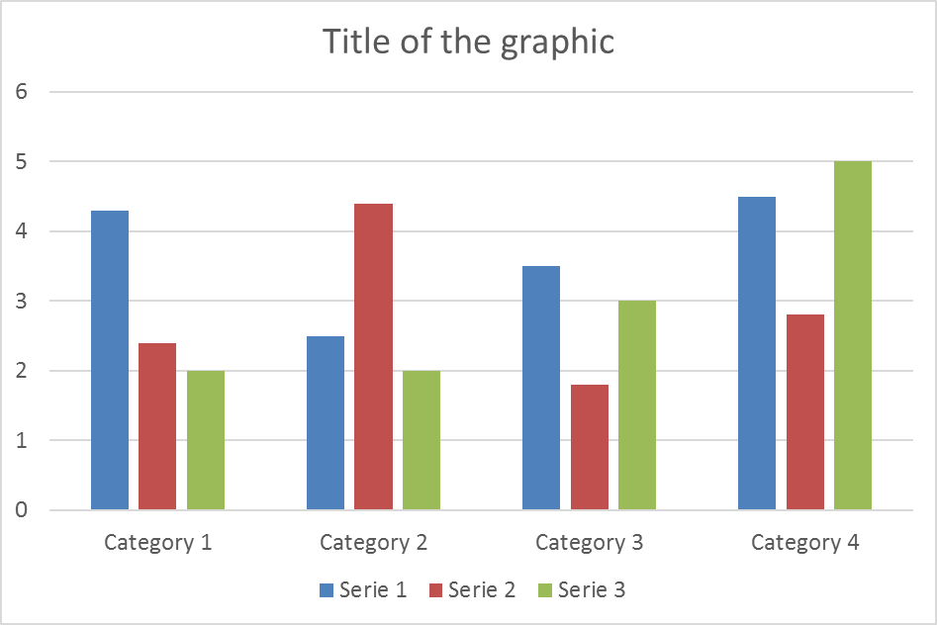

**Figure 1.** Figure captions should be written in sentence case – use this font and size (Book Antiqua 9) and leave 1 cm from each page margin. If present, footnotes should be Book Antiqua 8. Legends should be concise but explanatory. Do not use labels such as Fig., Scheme, Illustration, Graphics. Make sure that all Figures have been cited in the text properly. If you prefer to add a footnote under your figure caption, apply the same principles described for tables.

Do NOT leave blank lines after figure legends. Fix paragraph spacing as 12 pt before the text appearing right after the legend.

This is an open access article which is publicly available on our journal’s website under Institutional Repository at <http://dspace.marmara.edu.tr>.

|  |
| --- |
| **Acknowledgements:** Input text here.  **Author contributions:** Concept – B.Y., T.S.; Design – B.Y., T.S., E.T.; Supervision – T.S.; Resources – E.T., B.Y.; Materials – E.T.; Data Collection and/or Processing – B.Y., V.T.; Analysis and/or Interpretation – B.Y., N.Ş., V.T., T.S.; Literature Search – B.Y., N.Ş., T.S.; Writing – B.Y.; Critical Reviews – B.Y., N.Ş., V.T., E.T., T.S.  **Conflict of interest statement:** Fill in this section according to the signed conflict of interest statement when submitting your article. If there is no conflict of interest to be declared by any of the authors, write “The authors declared no conflict of interest” in the manuscript. |

**REFERENCES**

Avoid using personal communications, unpublished data, unpublished lecture notes, websites (refer to our author guideline for accepted websites) as references. Please check and ensure that, all references cited in the manuscript are present in the list of references, and all references listed in the reference list are cited in the manuscript. Journal titles should be abbreviated in accordance with the journal abbreviations in Thomson Reuters Web of Science, Index Medicus/ MEDLINE/PubMed. For all journal articles (including articles in press) in the reference list, the DOI numbers should be provided (ie. http://doi.org/10.1016/j.ejmech.2016.05.017).

*Examples*

The below references are given as examples. You can use PubMed (where available) for preparing your references in correct format (spacing, punctuation, journal abbreviations etc.). Please pay attention for the correctness of the references as it is a determinant for rapid typesetting return. The titles of journals in should be abbreviated according to the style used in the National Library of Medicine’s Journals in NCBI Databases. If you cannot find a particular journal title in the NLM database, check one of the following.

* ISI Journal Title Abbreviations
* CAS Source Index (CASSI) Search Tool
* ProQuest Serials Source list for Biological Sciences
* ProQuest Serials Source list for Biological Sciences

Please give all issue numbers after volume numbers in parentheses, if applicable (some journals do not apply issue numbers). First and last page numbers of the article should be given in full.

Please do not forget to delete this note, and sample references given below.

Do not let your word editor authomatically number your references. Give reference numbers manually.

*Reference to a journal publication*

[1] Tatar E, Karakuş S, Küçükgüzel ŞG, Öktem Okullu S, Ünübol N, Kocagöz T, De Clercq E, Andrei G, Snoeck R, Pannecouque C, Kalaycı S, Şahin F, Sriram D, Yogeeswari P, Küçükgüzel İ. Design, synthesis, and molecular docking studies of a conjugated thiadiazole-thiourea scaffold as antituberculosis agents. Biol Pharm Bull. 2016; 39(4): 502-515. <https://doi.org/10.1248/bpb.b15-00698>

[2] Tatar E, Küçükgüzel İ, Daelemans D, Talele TT, Kaushik-Basu N, De Clercq E, Pannecouque C. Some hydrazones of 2-aroylamino-3-methylbutanohydrazide: synthesis, molecular modeling studies, and identification as stereoselective inhibitors of HIV-1. Arch Pharm (Weinheim). 2013; 346(2): 140-153. <https://doi.org/10.1002/ardp.201200311>

[3] Manvar D, Küçükgüzel İ, Erensoy G, Tatar E, Deryabaşoğulları G, Reddy H, Talele TT, Çevik Ö, Kaushik-Basu N. Discovery of conjugated thiazolidinone-thiadiazole scaffold as anti-dengue virus polymerase inhibitors. Biochem Biophys Res Commun. 2016; 469(3): 743-747. <https://doi.org/10.1016/j.bbrc.2015.12.042>

[4] Booker A, Agapouda A, Frommenwiler DA, Scotti F, Reich E, Heinrich M. St John's wort (Hypericum perforatum) products - an assessment of their authenticity and quality. Phytomedicine. 2018; 40: 158-164. <https://doi.org/10.1016/j.phymed.2017.12.012>

[5] Sipahi H, Gostner JM, Becker K, Charehsaz M, Kirmizibekmez H, Schennach H, Aydin A, Fuchs D. Bioactivites of two common polyphenolic compounds: Verbascoside and catechin. Pharm Biol. 2016; 54(4): 712-719. <https://doi.org/10.3109/13880209.2015.1072830>

*Reference to a book:*

[6] Silverman RB, The Organic Chemistry of Drug Design and Drug Action, fourth ed., Elsever, Burlington, MA, USA 2000.

*Reference to a chapter in an edited book:*

[7] Şener G, Sakarcan A, Yeğen B. Melatonin as a radioprotective agent. In: Montilla P, Túnez I. (Eds). Melatonin: Present and Future. Nova Science Publishers, Inc., New York, 2008, pp.127-142.

*Theses:*

[8] Tatar E. PhD Thesis. Synthesis and characterization of novel 1,3-thiazolidine-4-ones derived from 2-(aroylamino)-3-methyl butyric acid hydrazide. Department of Pharmaceutical Chemistry, Faculty of Pharmacy, Marmara University, Haydarpaşa, İstanbul, Turkey, 2009.

*Reference to a website:*

[9] VCCLAB, Virtual Computational Chemistry Laboratory. http://www.vcclab.org (accessed on 18 March 2017).

[10] PASS (Prediction of Activity Spectra for Substances) program. http://www.way2drug.com/passonline (accessed on 18 July 2015).

[11] WHO Global tuberculosis report 2013. http://apps.who.int/iris/bitstream/10665/91355/1/9789241564656_eng.pdf?ua=1, (accessed on 18 July 2015).